A

MINI PROJECT REPORT

on
Hospital Emergency Queue Management
using Priority Queue
Submitted in partial fulfilment of the requirements for the award of the degree of
BACHELOR OF TECHNOLOGY
in
ARTIFICIAL INTELLIGENCE & MACHINE LEARNING
by

D.MANOJ KUMAR REDDY

(Roll No. 23AK1A3350)



CRT PLACEMENT CELL

ANNAMACHARYA INSTITUTE OF TECHNOLOGY AND SCIENCES, TIRUPATI (AUTONOMOUS)

Approved by AICTE, New Delhi & Permanent Affiliation to JNTUA, Anantapuramu.
Five B. Tech Programmes (ECE, CSE, EEE, CE, ME) are accredited by NBA, New Delhi.
Accredited by NAAC with 'A' Grade, Bangalore. Accredited by Institution of Engineers (India)KOLKATA.
A-grade awarded by AP Knowledge Mission. Recognized under sections 2(f) & 12(B) of UGC Act 1956.
Venkatapuram (V), Renigunta (M), Tirupati, Tirupati District, Andhra Pradesh – 517520.

2026-27

ACKNOWLEDGEMENT

I wish to express my profound gratitude to all those who contributed to the successful completion of the project titled “Hospital Emergency Queue Management System Using Priority Queue.”
I am sincerely thankful to the CRT Placement Cell for providing me with this valuable opportunity, which enabled me to strengthen my technical expertise and practical problem-solving skills.
I extend my deepest appreciation to the faculty members of the Department of Artificial Intelligence and Machine Learning, Annamacharya Institute of Technology and Sciences, Tirupati, for their insightful guidance, constructive feedback, and constant encouragement throughout the project.

D.MANOJ KUMAR REDDY
23AK1A3350

ABSTRACT

The Hospital Emergency Queue Management System Using Priority Queue is a software application developed to improve the management of patients in hospital emergency departments. In emergency situations, patients arrive with different levels of severity, making it essential to provide immediate attention to critical cases. Traditional queue systems often follow a first-come, first-served approach, which may not be suitable for emergency healthcare services.
This project implements a Priority Queue data structure to organize patients based on the severity of their medical condition. Patients with higher priority levels are treated before those with lower priority levels, ensuring efficient utilization of medical resources and reducing waiting time for critical patients.
The system is developed using Python, Tkinter, and MySQL. It provides functionalities such as patient registration, priority assignment, queue management, treatment status updates, and patient record maintenance. The graphical user interface makes the system easy to use for hospital staff.
The proposed system enhances emergency patient handling, improves operational efficiency, and ensures better healthcare service management through automated priority-based queue processing.

TABLE OF CONTENTS
- Introduction
- Existing System and Proposed System
2.1 Existing System
2.2 Proposed System
2.3 Advantages of Proposed System
- System Design
3.1 System Architecture
3.2 Workflow
- Database Design
- Module Description
5.1 Patient Registration
5.2 Search Patient
5.3 Update/Delete Patient
5.4 Treat Next Patient
5.5 Complete Treatment
- Implementation
- Results and Screenshots
- Conclusion and Future Scope and References
- Appendix – Source Code

CHAPTER 1

INTRODUCTION
Hospital emergency departments handle patients with different levels of medical urgency. During emergency situations, critical patients require immediate attention, while less severe cases can wait for treatment. Managing such patients manually may lead to delays, errors, and inefficient use of hospital resources.
The Hospital Emergency Queue Management System Using Priority Queue is developed to automate patient management in emergency departments. The system assigns priorities to patients based on the severity of their condition and ensures that critical patients receive treatment before serious and normal patients.
The application is developed using Python, Tkinter, and SQLite. It provides functionalities such as patient registration, patient search, record update, patient deletion, treatment management, and status tracking. The priority queue mechanism improves the efficiency of patient handling and reduces waiting time for emergency cases.
OBJECTIVES
• To automate emergency patient queue management.
• To prioritize patients based on the severity of their condition.
• To reduce waiting time for critical patients.
• To maintain patient records in a database.
• To provide an easy-to-use graphical interface for hospital staff.
• To improve the efficiency of emergency healthcare services.

CHAPTER 2
EXISTING SYSTEM AND PROPOSED SYSTEM
2.1 EXISTING SYSTEM
In many hospitals, patient management is performed manually or through basic registration systems. Patients are often treated on a first-come, first-served basis, which may not be suitable for emergency situations. This can increase waiting time for critically ill patients and make emergency patient handling less efficient.
2.2 PROPOSED SYSTEM
The Hospital Emergency Queue Management System Using Priority Queue automates emergency patient management. The system assigns priority levels such as Critical, Serious, and Normal to patients and ensures that higher-priority patients receive treatment first. Patient records are stored in a SQLite database and can be searched, updated, and managed easily through a graphical user interface.
2.3 ADVANTAGES OF PROPOSED SYSTEM
• Priority-based treatment management.
• Faster response for critical patients.
• Reduced patient waiting time.
• Accurate patient record maintenance.
• Automated queue management using priority queue concepts.

CHAPTER 3
SYSTEM DESIGN
3.1 SYSTEM ARCHITECTURE
The Hospital Emergency Queue Management System is designed using a three-layer architecture consisting of the User Interface Layer, Application Layer, and Database Layer. These components work together to provide efficient management of emergency patients and their treatment process.
The User Interface Layer is developed using Tkinter and provides screens for patient registration, searching records, updating information, deleting records, and treatment management. It acts as an interaction point between hospital staff and the system.
The Application Layer is implemented using Python. This layer performs all business operations such as patient ID generation, validation of user inputs, priority queue processing, treatment status updates, and database communication.
The Database Layer uses SQLite to store patient information permanently. All patient details, arrival times, priority levels, symptoms, and treatment statuses are maintained in the database.
System Architecture:
User (Hospital Staff)
|
Tkinter GUI
|
Python Logic
|
SQLite Database
3.2 WORKFLOW
The workflow of the system begins when a patient arrives at the hospital. The hospital staff enters the patient details such as name, age, symptoms, and priority level. The system automatically generates a unique Patient ID and stores the information in the database.
After registration, patients are arranged according to their priority levels. Critical patients are given the highest priority, followed by Serious and Normal patients. When treatment begins, the system automatically selects the highest-priority waiting patient.
Once treatment is completed, the patient's status is updated from "In Treatment" to "Completed". All records remain stored in the database for future reference and management.

Workflow:
Start
|
Patient Registration
|
Assign Priority
(Critical / Serious / Normal)
|
Store in Database
|
Display Queue
|
Treat Next Patient
|
Update Status
(In Treatment)
|
Complete Treatment
|
Update Status
(Completed)
|
End

CHAPTER 4
DATABASE DESIGN
The Hospital Emergency Queue Management System uses SQLite as the database management system to store and manage patient information. SQLite is a lightweight and serverless database that is suitable for desktop applications. It provides efficient storage, retrieval, and management of patient records.
The database maintains all essential patient details including patient ID, patient name, age, priority level, symptoms, arrival time, and treatment status. The stored information helps hospital staff efficiently manage emergency cases and monitor patient progress.
4.1 DATABASE NAME
Database Name: hospital.db
The database is automatically created when the application is executed for the first time. All patient records are stored in this database.
4.2 TABLE STRUCTURE
Table Name: patients
The patients table stores complete information about each patient registered in the system.
Field Name |  |  |  |  | Data Type |  |  |  | Description
patient_id |  |  |  |  | TEXT |  |  |  | Unique Patient ID (Primary Key)
patient_name |  |  |  |  | TEXT |  |  |  | Name of the Patient
age |  |  |  |  | INTEGER |  |  |  | Age of the Patient
priority |  |  |  |  | TEXT |  |  |  | Priority Level (Critical, Serious, Normal)
symptoms |  |  |  |  | TEXT |  |  |  | Symptoms of the Patient
arrival_time |  |  |  |  | TEXT |  |  |  | Date and Time of Arrival
status |  |  |  |  | TEXT |  |  |  | Current Treatment Status
4.3 PRIORITY LEVELS
The system classifies patients into three priority categories:
• Critical – Patients requiring immediate medical attention.
• Serious – Patients requiring treatment but not in life-threatening condition.
• Normal – Patients with less severe medical conditions.
The priority queue mechanism ensures that Critical patients are treated before Serious and Normal patients.
4.4 PATIENT STATUS
The treatment process is tracked using different patient statuses:
• Waiting – Patient is waiting for treatment.
• In Treatment – Patient is currently receiving treatment.
• Completed – Patient treatment has been successfully completed.
These statuses help hospital staff monitor patient progress efficiently.
CHAPTER 5
MODULE DESCRIPTION
The Hospital Emergency Queue Management System consists of various modules that help hospital staff manage emergency patients efficiently. Each module performs a specific operation and contributes to the smooth functioning of the system.
5.1 PATIENT REGISTRATION
The Patient Registration Module is used to add new patients to the system. Hospital staff enter patient details such as name, age, priority level, and symptoms. The system automatically generates a unique Patient ID and stores the information in the SQLite database.
5.2 SEARCH PATIENT
The Search Patient Module allows users to search for a patient using the Patient ID. Once the Patient ID is entered, the corresponding patient details are retrieved from the database and displayed on the screen. This helps in quick access to patient information.
5.3 UPDATE/DELETE PATIENT
This module allows hospital staff to modify or remove patient records. Existing patient information such as name, age, priority level, and symptoms can be updated whenever necessary. Unwanted or incorrect records can also be deleted from the database.
5.4 TREAT NEXT PATIENT
This module implements the Priority Queue concept. The system automatically selects the next patient for treatment based on the assigned priority level. Patients with Critical priority are treated first, followed by Serious and Normal patients. If multiple patients have the same priority level, the patient who arrived first is selected.
5.5 COMPLETE TREATMENT
The Complete Treatment Module updates the status of a patient after treatment is finished. The status changes from "In Treatment" to "Completed". This helps in tracking patient progress and maintaining treatment records effectively.

CHAPTER 6
IMPLEMENTATION
The Hospital Emergency Queue Management System is implemented using Python, Tkinter, and SQLite. The application provides a graphical user interface for managing emergency patients and uses a priority queue mechanism to ensure that critical patients receive treatment first.
6.1 TECHNOLOGIES USED
• Python – Used for application development and business logic.
• Tkinter – Used to create the graphical user interface.
• SQLite – Used to store and manage patient records.
6.2 DATABASE CREATION
The SQLite database is used to store patient information permanently. The following code creates the patients table.
conn = sqlite3.connect("hospital.db")
cursor = conn.cursor()
cursor.execute("""
CREATE TABLE IF NOT EXISTS patients (
patient_id TEXT PRIMARY KEY,
patient_name TEXT,
age INTEGER,
priority TEXT,
symptoms TEXT,
arrival_time TEXT,
status TEXT
)
""")
6.3 PATIENT ID GENERATION
A unique Patient ID is automatically generated for every new patient registered in the system.

def generate_patient_id():
cursor.execute("""
SELECT patient_id
FROM patients
ORDER BY patient_id DESC
LIMIT 1
""")
6.4 PRIORITY QUEUE IMPLEMENTATION
The system selects the next patient based on priority level. Critical patients are treated before Serious and Normal patients.
def treat_next_patient():
cursor.execute("""
SELECT *
FROM patients
WHERE status='Waiting'
ORDER BY
CASE priority
WHEN 'Critical' THEN 1
WHEN 'Serious' THEN 2
WHEN 'Normal' THEN 3
END,
arrival_time
LIMIT 1
""")
The implementation successfully manages patient records, assigns priorities, and ensures efficient emergency patient handling using the Priority Queue concept.

CHAPTER 7
RESULTS AND SCREENSHOTS
The Hospital Emergency Queue Management System Using Priority Queue was successfully developed and tested. The application performs patient registration, patient record management, priority-based treatment assignment, and treatment status tracking efficiently. The system ensures that critical patients receive treatment before serious and normal patients.
7.1 MAIN GUI SCREEN
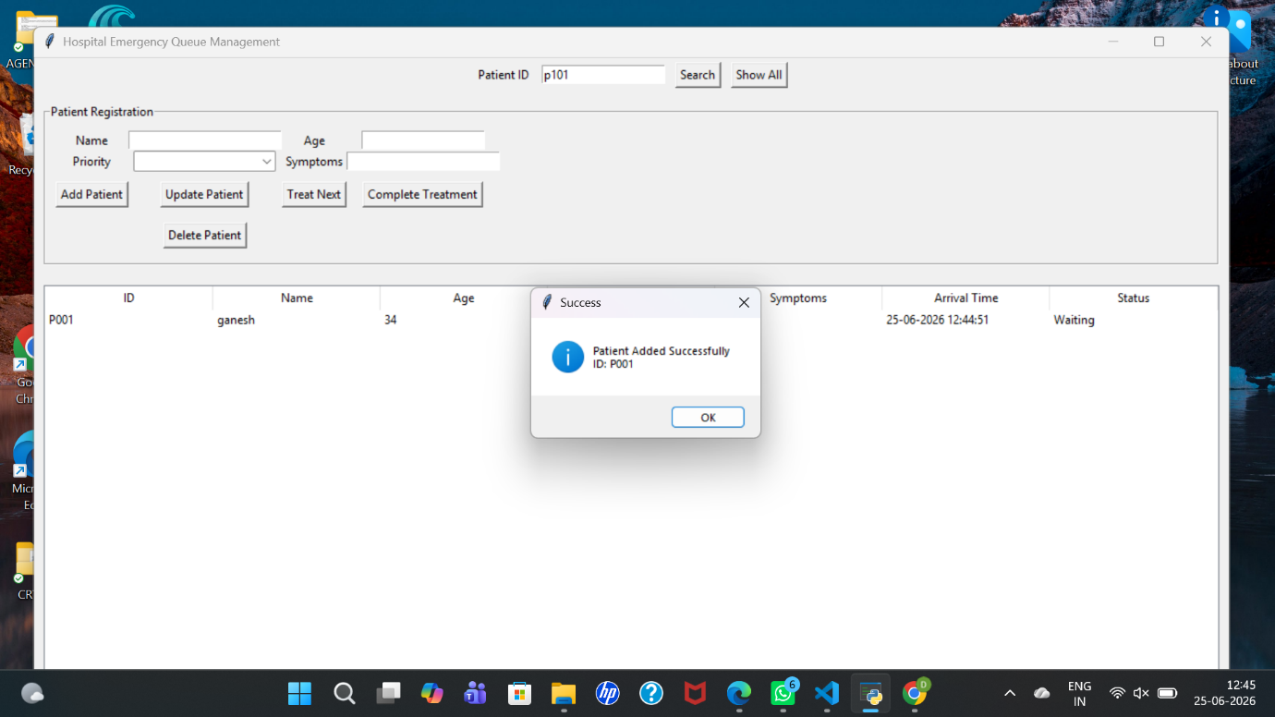
Description:
The main graphical user interface provides access to all system functionalities. It contains options for patient registration, search, update, deletion, treatment management, and display of patient records.
7.2 PATIENT REGISTRATION AND RECORD DISPLAY
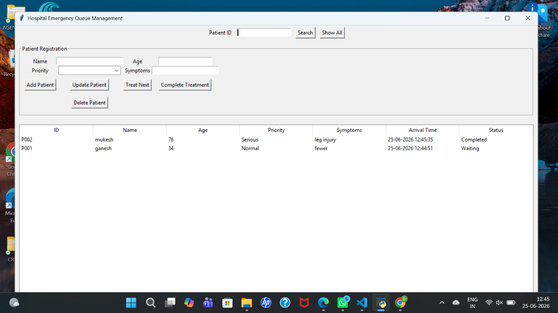

Description:
This screen displays the successful registration of a patient. The system automatically generates a unique Patient ID and stores the patient information in the SQLite database. All patient records are displayed in a tabular format.
7.3 PRIORITY-BASED TREATMENT SELECTION
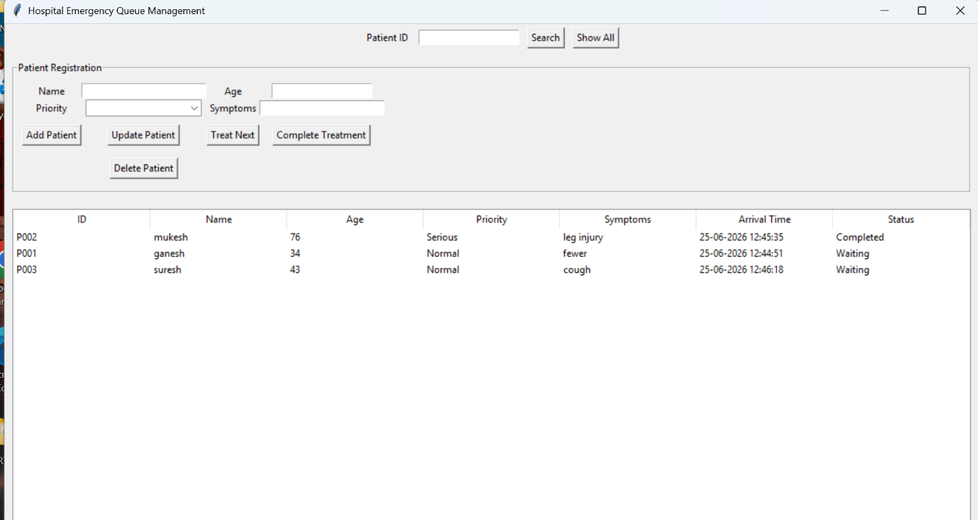
Description:
This screen demonstrates the implementation of the Priority Queue concept. The system automatically selects the highest-priority waiting patient for treatment. Critical patients are treated before Serious and Normal patients.
RESULT
The Hospital Emergency Queue Management System was successfully implemented using Python, Tkinter, and SQLite. The application efficiently manages emergency patient records, reduces waiting time for critical patients, and provides a user-friendly interface for hospital staff. The Priority Queue mechanism ensures effective and organized patient treatment management.

CHAPTER 8
CONCLUSION AND FUTURE SCOPE
CONCLUSION
The Hospital Emergency Queue Management System Using Priority Queue was successfully developed using Python, Tkinter, and SQLite. The system provides an efficient way to manage emergency patients by assigning priorities based on the severity of their condition.
The application allows hospital staff to register patients, search records, update information, delete records, assign treatment, and complete treatment processes. The implementation of the Priority Queue concept ensures that critical patients receive medical attention before serious and normal patients.
The system improves patient management, reduces waiting time, and enhances the efficiency of emergency healthcare services.
FUTURE SCOPE
• Integration with cloud databases for centralized data management.
• Online patient registration and appointment booking.
• Doctor allocation and scheduling system.
• SMS and Email notifications for patient updates.
• AI-based patient severity prediction and decision support.
• Multi-hospital patient record management.
REFERENCES
- Python Documentation – https://docs.python.org
- Tkinter Documentation – https://docs.python.org/3/library/tkinter.html
- SQLite Documentation – https://www.sqlite.org/docs.html
- Python SQLite3 Module Documentation – https://docs.python.org/3/library/sqlite3.html
- GeeksforGeeks – Python GUI and Database Concepts.

CHAPTER 9
APPENDIX A – SOURCE CODE
import tkinter as tk
from tkinter import ttk, messagebox
import sqlite3
from datetime import datetime
# ================= DATABASE =================
conn = sqlite3.connect("hospital.db")
cursor = conn.cursor()
cursor.execute("""
CREATE TABLE IF NOT EXISTS patients (
patient_id TEXT PRIMARY KEY,
patient_name TEXT,
age INTEGER,
priority TEXT,
symptoms TEXT,
arrival_time TEXT,
status TEXT
)
""")
conn.commit()
# ================= FUNCTIONS =================
def generate_patient_id():
cursor.execute("""
SELECT patient_id
FROM patients
ORDER BY patient_id DESC
LIMIT 1
""")
row = cursor.fetchone()
if row:
last_id = int(row[0][1:])
return f"P{last_id + 1:03d}"
return "P001"
def clear_fields():
entry_name.delete(0, tk.END)
entry_age.delete(0, tk.END)
entry_symptoms.delete(0, tk.END)
combo_priority.set("")
def load_patients():
for item in tree.get_children():
tree.delete(item)
cursor.execute("""
SELECT * FROM patients
ORDER BY
CASE priority
WHEN 'Critical' THEN 1
WHEN 'Serious' THEN 2
WHEN 'Normal' THEN 3
END,
arrival_time
""")
for row in cursor.fetchall():
tree.insert("", tk.END, values=row)
def add_patient():
name = entry_name.get().strip()
age = entry_age.get().strip()
priority = combo_priority.get()
symptoms = entry_symptoms.get().strip()
if not all([name, age, priority, symptoms]):
messagebox.showerror("Error", "Fill all fields")
return
try:
age = int(age)
except ValueError:
messagebox.showerror("Error", "Age must be numeric")
return
pid = generate_patient_id()
arrival = datetime.now().strftime("%d-%m-%Y %H:%M:%S")
cursor.execute("""
INSERT INTO patients
VALUES (?, ?, ?, ?, ?, ?, ?)
""", (pid, name, age, priority, symptoms, arrival, "Waiting"))
conn.commit()
load_patients()
clear_fields()
messagebox.showinfo("Success", f"Patient Added Successfully\nID: {pid}")
def search_patient():
pid = entry_search.get().strip()
if not pid:
messagebox.showerror("Error", "Enter Patient ID")
return
cursor.execute("SELECT * FROM patients WHERE patient_id=?", (pid,))
row = cursor.fetchone()
for item in tree.get_children():
tree.delete(item)

if row:
tree.insert("", tk.END, values=row)
entry_name.delete(0, tk.END)
entry_name.insert(0, row[1])
entry_age.delete(0, tk.END)
entry_age.insert(0, row[2])
combo_priority.set(row[3])
entry_symptoms.delete(0, tk.END)
entry_symptoms.insert(0, row[4])
else:
messagebox.showinfo("Search", "Patient Not Found")
def update_patient():
selected = tree.focus()
if not selected:
messagebox.showerror("Error", "Select a patient")
return
pid = tree.item(selected)["values"][0]
name = entry_name.get().strip()
age = entry_age.get().strip()
priority = combo_priority.get()
symptoms = entry_symptoms.get().strip()
if not all([name, age, priority, symptoms]):
messagebox.showerror("Error", "Fill all fields")
return
try:
age = int(age)
except ValueError:
messagebox.showerror("Error", "Age must be numeric")
return

cursor.execute("""
UPDATE patients
SET patient_name=?, age=?, priority=?, symptoms=?
WHERE patient_id=?
""", (name, age, priority, symptoms, pid))
conn.commit()
load_patients()
messagebox.showinfo("Success", "Patient Updated Successfully")
def delete_patient():
selected = tree.focus()
if not selected:
messagebox.showerror("Error", "Select a patient")
return
pid = tree.item(selected)["values"][0]
cursor.execute("DELETE FROM patients WHERE patient_id=?", (pid,))
conn.commit()
load_patients()
messagebox.showinfo("Deleted", "Patient Deleted Successfully")
def select_record(event):
selected = tree.focus()
if not selected:
return
values = tree.item(selected)["values"]
entry_name.delete(0, tk.END)
entry_name.insert(0, values[1])
entry_age.delete(0, tk.END)
entry_age.insert(0, values[2])

combo_priority.set(values[3])
entry_symptoms.delete(0, tk.END)
entry_symptoms.insert(0, values[4])
def treat_next_patient():
cursor.execute("""
SELECT *
FROM patients
WHERE status='Waiting'
ORDER BY
CASE priority
WHEN 'Critical' THEN 1
WHEN 'Serious' THEN 2
WHEN 'Normal' THEN 3
END,
arrival_time
LIMIT 1
""")
patient = cursor.fetchone()
if not patient:
messagebox.showinfo("Queue", "No waiting patients")
return
cursor.execute("""
UPDATE patients
SET status='In Treatment'
WHERE patient_id=?
""", (patient[0],))
conn.commit()
load_patients()
messagebox.showinfo(
"Next Patient",
f"Treat Patient: {patient[0]} - {patient[1]}"
)
def complete_treatment():
cursor.execute("""
SELECT patient_id
FROM patients
WHERE status='In Treatment'
LIMIT 1
""")
patient = cursor.fetchone()
if not patient:
messagebox.showinfo(
"Info",
"No patient is currently in treatment"
)
return
cursor.execute("""
UPDATE patients
SET status='Completed'
WHERE patient_id=?
""", (patient[0],))
conn.commit()
load_patients()
messagebox.showinfo(
"Success",
f"Patient {patient[0]} treatment completed"
)
# ================= GUI =================
root = tk.Tk()
root.title("Hospital Emergency Queue Management")
root.geometry("1200x650")
# Search Frame
search_frame = tk.Frame(root)
search_frame.pack(pady=5)
tk.Label(search_frame, text="Patient ID").pack(side=tk.LEFT, padx=5)
entry_search = tk.Entry(search_frame)
entry_search.pack(side=tk.LEFT, padx=5)
tk.Button(search_frame, text="Search",
command=search_patient).pack(side=tk.LEFT, padx=5)
tk.Button(search_frame, text="Show All",
command=load_patients).pack(side=tk.LEFT, padx=5)
# Form
form = tk.LabelFrame(root, text="Patient Registration",
padx=10, pady=10)
form.pack(fill="x", padx=10, pady=10)
tk.Label(form, text="Name").grid(row=0, column=0)
entry_name = tk.Entry(form, width=25)
entry_name.grid(row=0, column=1)
tk.Label(form, text="Age").grid(row=0, column=2)
entry_age = tk.Entry(form, width=20)
entry_age.grid(row=0, column=3)
tk.Label(form, text="Priority").grid(row=1, column=0)
combo_priority = ttk.Combobox(
form,
values=["Critical", "Serious", "Normal"],
state="readonly"
)
combo_priority.grid(row=1, column=1)
tk.Label(form, text="Symptoms").grid(row=1, column=2)
entry_symptoms = tk.Entry(form, width=25)
entry_symptoms.grid(row=1, column=3)
tk.Button(form, text="Add Patient",
command=add_patient).grid(row=2, column=0, pady=10)
tk.Button(form, text="Update Patient",
command=update_patient).grid(row=2, column=1)
tk.Button(form, text="Treat Next",
command=treat_next_patient).grid(row=2, column=2)
tk.Button(form, text="Complete Treatment",
command=complete_treatment).grid(row=2, column=3)
tk.Button(form, text="Delete Patient",
command=delete_patient).grid(row=3, column=1, pady=5)
# Table
columns = (
"ID", "Name", "Age",
"Priority", "Symptoms",
"Arrival Time", "Status"
)
tree = ttk.Treeview(root, columns=columns, show="headings")
for col in columns:
tree.heading(col, text=col)
tree.column(col, width=160)
tree.pack(fill="both", expand=True, padx=10, pady=10)
tree.bind("<<TreeviewSelect>>", select_record)
load_patients()
root.mainloop()
conn.close()

